Software Requirements Specification (SRS)
Web-Based ML Model Evaluator
Part B: Sections 4 to 8 (Member 2 deliverable)
Project | Web-Based ML Model Evaluator (WBMME)
Repository | SE_498_515_534_911
Version / status | 0.1 / Draft for team review
Author | Member 2
Date | 12-10-2026
Merges into | The WBMME SRS after Part A (Sections 1 and 2, Member 1). Section numbers below are the final SRS numbers.
Related documents | SAD Sections 3.3 to 3.9 (Member 3), Test Plan (Members 1 to 4), Mini-Project Deliverables Part-1 and Part-2

REVIEW NOTES FOR THE TEAM (delete this box before merging)
- IDs are unchanged. MLE-F-001 to 016, MLE-NF-001 to 005 and MLE-SR-001 to 005 are exactly as in SAD 3.8 and the Test Plan, so nothing needs renaming. New: MLE-NF-006 (reliability), MLE-NF-007 (scalability), MLE-SR-006 (availability limits), MLE-SR-007 (session, login throttling, CSRF) and objectives MLE-SO-001 to 003. Each new item is marked “(new)”.
- Security matches SAD 3.9. Objectives are confidentiality, integrity and availability, worded as in SAD 3.9, and sit in section 5.1.1 as SAD 3.9 states. Section 5.1.3 maps every STRIDE row of SAD 3.9 to a requirement.
- Values I chose that no other document fixes: 120 requests/min, 300 s job time-out, 2 active jobs per user (1 for Student), 30 min session, 5 failed logins in 10 min then 15 min block, 50,000 rows / 100 columns / 20 datasets limits, 20 feature columns in MLE-NF-002, and the four-model catalogue. Please confirm or change them.
- Scope assumption: version 1.0 evaluates classification models only (metrics and the target rule in Table 4.2-1 depend on it).

4. System features (detailed)
This section specifies the functional requirements of WBMME, grouped by system feature in the style of the IEEE SRS template: description and priority, stimulus/response sequences, then the numbered requirements. Every requirement has a unique ID (MLE-F-nnn), uses “shall” for mandatory behaviour, states a measurable limit where one applies, and names how it will be verified.
Priority. High: needed for the minimal end-to-end flow. Medium: needed for a complete release. Low: may be deferred if the two-sprint schedule requires it (SAD 3.7, risk R8).

4.1 Authentication and access control

4.1.1 Description and priority
Lets a person create an account, log in, and use only the functions that their role allows. Three roles exist: Student, Data Scientist and Admin (SRS 2.3).
Priority: High. Every other feature depends on it, and it carries security objectives MLE-SO-001 and MLE-SO-002.
Table 4.1-1: Permissions by role
Capability | Student | Data Scientist | Admin
Register an account | Yes | Yes | No (created by an Admin or at installation)
Log in and log out | Yes | Yes | Yes
Upload, prepare and delete own datasets | Yes | Yes | No
Select a model, train and evaluate | Yes | Yes | No
View, compare and export own runs | Yes | Yes | No
Active training jobs at one time (MLE-SR-006) | 1 | 2 | Not applicable
List users, change roles, deactivate accounts | No | No | Yes
List and delete any dataset (metadata only) | No | No | Yes
View the audit log | No | No | Yes
Read another user’s datasets, models or results | No | No | No

4.1.2 Stimulus/response sequences
- A visitor submits the registration form with valid data: the system creates the account with the chosen role (Student or Data Scientist) and shows the login page. With invalid data the form is shown again with a message per faulty field and no account is created.
- A user submits valid credentials: the system starts a session and shows the dashboard. With invalid credentials the system shows one generic message (“Invalid username or password”) and starts no session.
- A logged-in user requests a page or API endpoint that the role does not permit: the system refuses the request (HTTP 403 or 404) and returns no data.
- A user selects Log out, or stays inactive for 30 minutes: the session ends and the login page is shown.

4.1.3 Functional requirements
ID | Requirement | Priority | Verification
MLE-F-001 | The system shall let a visitor register with a unique username (3 to 30 characters: letters, digits and underscore), a valid e-mail address and a password of at least 8 characters that contains at least one letter and one digit, and shall let a registered user log in with username and password and log out. A failed login shall be refused with one generic message that does not reveal whether the username or the password was wrong. A deactivated account shall not be able to log in. | High | Test: TC-AUTH-01
MLE-F-002 | The system shall assign every account exactly one role (Student, Data Scientist or Admin) and shall check the role on every page and API endpoint. Any access not explicitly permitted by Table 4.1-1 shall be denied with HTTP 403 or 404. Self-registration shall create only Student or Data Scientist accounts; the Admin role shall be assigned only by an existing Admin or at installation. Administration pages and endpoints shall be reachable only by the Admin role. | High | Test: TC-SEC-01

4.2 Data workspace (dataset upload and preparation)

4.2.1 Description and priority
Accepts a CSV dataset, validates it, shows what it contains, and prepares it for training (missing values, categorical encoding, target column and train/test split).
Priority: High. This is the first stage of the pipeline: Upload, Preprocess, Train, Evaluate, Record (SAD 3.5).
Table 4.2-1: Dataset and upload limits (used by MLE-F-003, MLE-F-006 and MLE-SR-003)
Parameter | Limit
File type | .csv only, UTF-8, comma-delimited, first row is the header
Maximum file size | 10 MB (a file of exactly 10 MB is accepted; larger files are rejected)
Rows | At least 20 and at most 50,000 data rows
Columns | At least 2 and at most 100 columns; every data row has the same number of fields as the header
Datasets per user | At most 20 stored datasets
Target column | Between 2 and 20 distinct values; every class has at least 2 rows
Cell content | Always handled as data. A cell that starts with =, +, - or @ is never evaluated.

4.2.2 Stimulus/response sequences
- A user uploads a file that passes validation: the system stores it in the user’s own directory and shows a preview and profile of the data.
- A user uploads a file that fails validation (wrong type, too large, empty, malformed): the system stores nothing and shows a message that names the reason.
- A user chooses a missing-value treatment and categorical encoding: the system confirms the settings and applies them when the split is created.
- A user selects the target column and test share: the system creates a stratified split, or refuses the choice and explains why (for example, fewer than two classes).

4.2.3 Functional requirements
ID | Requirement | Priority | Verification
MLE-F-003 | The system shall accept a dataset upload only when the file meets every limit in Table 4.2-1, and shall store each accepted file in the uploading user’s own directory. A rejected file shall not be stored, and the user shall receive a message that states the reason (wrong type, too large, empty or malformed). The owner shall be able to delete their own datasets. | High | Test: TC-DATA-01, TC-DATA-02
MLE-F-004 | For every accepted dataset the system shall display the first 20 rows and a profile that gives the row count, the column names, the inferred type of each column (numeric or categorical) and the number of missing values in each column. The profile values shall equal values computed independently from the file. | High | Test: TC-DATA-01
MLE-F-005 | The system shall let the user choose one treatment for missing values per dataset (drop the rows; fill numeric columns with the mean or the median; fill categorical columns with the most frequent value) and shall one-hot encode categorical feature columns. Both steps shall be fitted on the training split only and then applied to the test split. | High | Test: planned, Sprint 1
MLE-F-006 | The system shall let the user select the target column, the share of rows used for testing (10% to 50% in steps of 5%, default 20%) and an integer random seed (default 42), and shall create a stratified split. The system shall refuse a target column that does not meet the target rule in Table 4.2-1 and shall state the reason. | High | Test: TC-MODEL-01

4.3 Model selection and training

4.3.1 Description and priority
Lets a user choose a classification algorithm from a fixed catalogue, set its parameters, and train it on the prepared data as a background job.
Priority: High. It is the core of the evaluator.
Table 4.3-1: Model catalogue and permitted hyperparameters
Model | Hyperparameter and permitted range | Default
Logistic Regression | C: 0.01 to 100. max_iter: 100 to 1000. | C = 1.0, max_iter = 200
k-Nearest Neighbours | n_neighbors: 1 to 50. weights: uniform or distance. | n_neighbors = 5, uniform
Decision Tree | max_depth: 1 to 50 or no limit. min_samples_split: 2 to 20. | No depth limit, min_samples_split = 2
Random Forest | n_estimators: 10 to 200. max_depth: 1 to 50 or no limit. | n_estimators = 100, no depth limit

4.3.2 Stimulus/response sequences
- A user selects a model: the system shows its default parameters (Table 4.3-1).
- A user enters a parameter value outside the permitted range: the system refuses it and names the parameter and its range. Training does not start.
- A user starts training: the system queues the job and shows the status Queued, then Running, then Completed or Failed.
- A user who already has the maximum number of active jobs starts another one: the system refuses it and states the limit (MLE-SR-006).

4.3.3 Functional requirements
ID | Requirement | Priority | Verification
MLE-F-007 | The system shall offer a catalogue of at least four classification algorithms (Logistic Regression, k-Nearest Neighbours, Decision Tree and Random Forest; Table 4.3-1) and shall let the user select exactly one per run. The catalogue is fixed: the system shall not accept a user-supplied model or algorithm. | High | Test: TC-MODEL-01
MLE-F-008 | For the selected model the system shall let the user edit at least two hyperparameters within the ranges in Table 4.3-1 and shall refuse any value outside its range, before training starts, with a message that names the parameter and its permitted range. | Medium | Test: TC-MODEL-01
MLE-F-009 | The system shall train the selected model on the training split as a background job, shall show the job status as Queued, Running, Completed or Failed, and shall store the trained model so that only the owning user can use it. The user interface shall stay usable while a job runs. | High | Test: TC-MODEL-01

4.4 Evaluation and explainability

4.4.1 Description and priority
Measures a trained model against the held-out test split and presents the result as numbers and charts.
Priority: High for metrics and charts (MLE-F-010, F-011); Medium for feature importance (MLE-F-012).

4.4.2 Stimulus/response sequences
- A user opens the results page of a completed run: the system shows accuracy, precision, recall, F1 and (where available) ROC-AUC.
- The user opens the charts: the system shows the confusion matrix and a bar chart of the metrics.
- The user opens feature importance: the system lists features by importance, or states that the chosen model does not provide it.

4.4.3 Functional requirements
ID | Requirement | Priority | Verification
MLE-F-010 | For every completed run the system shall compute accuracy, precision, recall and F1-score on the test split (macro-averaged when the target has more than two classes) and ROC-AUC when the model provides probability estimates. Each value shall equal the scikit-learn reference value for the same split and seed within 0.001. | High | Test: TC-EVAL-01
MLE-F-011 | For every completed run the system shall display a confusion matrix whose cell counts add up to the number of rows in the test split, and a bar chart of the metrics defined in MLE-F-010. | High | Test: TC-EVAL-01
MLE-F-012 | For models that provide feature importance (Logistic Regression coefficients, Decision Tree and Random Forest importances) the system shall list every feature with its importance in descending order. For other models it shall state that feature importance is not available. SHAP explanations are optional and are not committed by this SRS. | Medium | Test: planned, Sprint 2

4.5 Experiment management and reporting

4.5.1 Description and priority
Keeps a record of every run so that results can be reviewed, compared and exported.
Priority: High for saving runs (MLE-F-013); Medium for comparison and export (MLE-F-014, F-015).

4.5.2 Stimulus/response sequences
- A run finishes (Completed or Failed): the system saves it automatically and lists it in the history, newest first.
- A user selects two to four runs on the same dataset and target and chooses Compare: the system shows their settings and metrics side by side.
- A user selects runs on different datasets: the system refuses and explains that only runs on the same dataset and target can be compared.
- A user chooses Export: the system downloads a CSV file with the settings and metrics of the selected run or comparison.

4.5.3 Functional requirements
ID | Requirement | Priority | Verification
MLE-F-013 | The system shall save every run automatically with its owner, dataset, target column, split settings, model, parameters, status, metrics, start time and end time, and shall list the owner’s runs newest first. A saved run shall be kept until its owner deletes it. | High | Test: TC-EXP-01
MLE-F-014 | The system shall let the user select two to four of their own runs on the same dataset and target column and shall show their parameters and metrics side by side. The displayed values shall equal those on each run’s own page. The system shall refuse a selection that mixes datasets or target columns and shall explain why. | Medium | Test: TC-EXP-01
MLE-F-015 | The system shall export a run, or a comparison of runs, as a CSV file that contains the run settings and metrics. Any exported cell that begins with =, +, - or @ shall be neutralised so that a spreadsheet program does not evaluate it as a formula. PDF export is desirable but is not committed by this SRS. | Medium | Test: TC-DATA-02 (step 3); full export test planned, Sprint 2

4.6 Administration

4.6.1 Description and priority
Lets an Admin manage user accounts and stored datasets and review the audit log, without being able to read users’ data.
Priority: High. Needed to manage accounts and to review the audit log required by MLE-SR-005.

4.6.2 Stimulus/response sequences
- An Admin opens user management: the system lists all accounts with role and status, and offers Change role and Deactivate or Reactivate for each.
- An Admin deletes a dataset: the system asks for confirmation, removes the file and its metadata, and writes an audit-log entry.
- An Admin opens the audit log: the system lists entries newest first with user ID, action and timestamp.
- A non-Admin requests any of these pages: the system refuses the request (MLE-F-002).

4.6.3 Functional requirements
ID | Requirement | Priority | Verification
MLE-F-016 | The system shall let an Admin list all user accounts, change a user’s role, deactivate and reactivate an account, list the metadata (name, owner, size and upload date) of all datasets, delete any dataset, and view the audit log defined in MLE-SR-005. The application shall not let an Admin view the contents of another user’s dataset. | High | Test: TC-SEC-01

5. Non-functional requirements (detailed)
Non-functional requirements are identified as MLE-NF-nnn (quality and performance) and MLE-SR-nnn (security). Each states a measurable target and a verification method. Security comes first (section 5.1) because it carries the three security objectives referenced by SAD 3.9.

5.1 Security
The objectives and requirements below are aligned with the STRIDE threat model and the security architecture in SAD 3.9. Section 5.1.3 shows the mapping row by row.

5.1.1 Security objectives
ID | Objective | STRIDE threats addressed | Requirements that deliver it
MLE-SO-001  Confidentiality | Confidentiality of each user’s datasets, models and results.  Only the owner (and, for account and dataset management, an Admin) can read or change a user’s data. Credentials, sessions and traffic are protected from disclosure. | Spoofing, Information disclosure, Elevation of privilege | MLE-SR-001, SR-002, SR-005(a), SR-007; MLE-F-002
MLE-SO-002  Integrity | Integrity of uploaded data, trained models and reported metrics.  Uploaded files are validated before use, only artifacts created by the system are loaded, and every change is attributable to a user. | Tampering, Repudiation | MLE-SR-003, SR-004, SR-005(b)
MLE-SO-003  Availability | Availability of the service against abusive or oversized requests.  Request size, request rate, concurrent jobs and job run time are bounded so that one user cannot exhaust the server. | Denial of service | MLE-SR-006

5.1.2 Security requirements
ID | Requirement | Objective | Threat | Verified by
MLE-SR-001 | The system shall store passwords only as salted hashes created with PBKDF2 or bcrypt, and shall never display or log a password. | Confidentiality | Spoofing | Test: TC-AUTH-01 (step 5); inspection
MLE-SR-002 | On the deployed build, all traffic between browser and server shall use HTTPS with TLS 1.2 or higher. Plain HTTP requests shall be redirected to HTTPS or refused, and TLS 1.0 and 1.1 shall be refused. (Local development builds are exempt.) | Confidentiality | Information disclosure | Test: SV-02 (TLS scan of the deployed build)
MLE-SR-003 | The system shall accept an upload only when its extension is .csv, its declared MIME type is text/csv or text/plain, its size is within Table 4.2-1, and its content parses as a CSV file with a consistent number of columns. Uploaded content shall never be executed or deserialised, and rejected uploads shall not be stored. | Integrity | Tampering | Test: TC-DATA-02
MLE-SR-004 | The system shall load only model artifacts that it created itself, shall not accept an uploaded model file through any page or endpoint, and shall store artifacts in per-user directories outside the web root, so that no artifact can be requested by a URL. | Integrity | Tampering, Elevation of privilege | Test: SV-04; code inspection
MLE-SR-005 | (a) Every read, change or delete of a dataset, run or artifact shall first check that the requester owns it (or is an Admin where MLE-F-016 allows), and shall otherwise return a generic 403 or 404 response that does not reveal whether the item exists. (b) The system shall write an audit-log entry with user ID, timestamp and action for every login (successful and failed), upload, training, deletion and Admin action. The log shall contain no raw dataset values and no credentials. | Confidentiality, Integrity | Information disclosure, Repudiation | Test: TC-SEC-01
MLE-SR-006  (new) | The system shall (a) reject a request body larger than 10 MB with HTTP 413; (b) allow at most 120 requests per minute per authenticated user, and per IP address for anonymous requests, and answer any excess with HTTP 429; (c) allow each user at most 2 queued or running training jobs (1 for the Student role) and refuse further jobs with a message; and (d) stop any training job that runs longer than 300 seconds and set the run to Failed with the reason “time-out”. | Availability | Denial of service | Test: SV-06
MLE-SR-007  (new) | The system shall (a) end a session after 30 minutes of inactivity; (b) mark session cookies HttpOnly, and Secure on HTTPS deployments; (c) block login for an account for 15 minutes after 5 consecutive failed logins within 10 minutes; and (d) refuse, with HTTP 403, every state-changing request (POST, PUT, PATCH, DELETE) that does not carry a valid CSRF token. | Confidentiality | Spoofing | Test: TC-AUTH-01 (cookie flag), SV-07, SV-08

5.1.3 Mapping to the SAD 3.9 threat model
STRIDE threat (SAD 3.9) | Mitigation named in SAD 3.9 | SRS requirement
Spoofing | Hashed passwords, session expiry, login throttling, secure and HttpOnly cookies | MLE-SR-001, MLE-SR-007
Tampering | File type, size and content validation; artifacts outside the web root; load only system-generated artifacts; no unpickling of user files | MLE-SR-003, MLE-SR-004
Repudiation | Audit log of logins, uploads, trainings, deletions and admin actions with user ID and timestamp | MLE-SR-005(b)
Information disclosure | Ownership check on every query and file path; HTTPS (TLS 1.2+); generic error messages; no raw data in logs | MLE-SR-002, MLE-SR-005(a)
Denial of service | Upload size limit, row and column limits, rate limiting, per-user job quota, training time-out | MLE-SR-006; row and column limits in MLE-F-003 (Table 4.2-1)
Elevation of privilege | Role-based access control on every view and endpoint; admin routes separated; deny by default | MLE-F-002 (also MLE-F-016, MLE-SR-004)

5.2 Performance requirements
Rationale: Students and data scientists work interactively, so the limits keep waiting time short at the supported dataset sizes. All timings are taken on one fixed reference test machine, whose specification is recorded in the Test Plan (section 6).
ID | Requirement | Priority | Verification
MLE-NF-001 | For a valid CSV file of up to 10 MB, the time from submitting the upload until the dataset profile is displayed shall be 5 seconds or less in each of five consecutive runs, on the reference test machine with one active user. | High | Test: TC-PERF-01
MLE-NF-002 | Training any catalogue model with its default parameters on a dataset of up to 50,000 rows and 20 feature columns shall complete in 60 seconds or less, and the dashboard shall stay responsive while the job runs. | High | Test: TC-PERF-02
MLE-NF-003 | With 20 concurrent logged-in users, every application page shall load in 3 seconds or less, for both the average and the 95th percentile, over a run of 5 minutes, and the run shall produce no server errors (HTTP 5xx). | Medium | Test: TC-PERF-03

5.3 Reliability requirements
Rationale: Training depends on user-supplied data, so failures are expected. They must not affect other users or lose saved results.
ID | Requirement | Priority | Verification
MLE-NF-006  (new) | When a training job fails (invalid data, time-out or internal error), the system shall set the run to Failed with a plain-language reason, shall store no partial model, and shall stay available to other users. Users, datasets and runs saved before a server restart shall all be present after it. | Medium | Test: fault-injection test and restart test (planned, Sprint 2)

5.4 Scalability requirements
Rationale: The history and dataset lists grow with every experiment and must stay fast.
ID | Requirement | Priority | Verification
MLE-NF-007  (new) | The system shall support at least 20 stored datasets and 100 stored runs per user and shall keep the page-load limit of MLE-NF-003 for the history and dataset lists, which shall be paginated at 20 items per page. | Low | Test: load test with seeded data (planned, Sprint 2)

5.5 Portability requirements
Rationale: Team members develop on different operating systems. Docker gives one reproducible environment (SAD 3.6).
ID | Requirement | Priority | Verification
MLE-NF-004 | The system shall build and start from the repository with Docker on Windows, Linux and macOS using one documented command, and its pages shall work in the current versions of Google Chrome and Mozilla Firefox. | Medium | Test: build and smoke test on each OS (planned, Sprint 2)

5.6 Usability requirements
Rationale: The Student user class has limited machine-learning experience (SRS 2.3), so the interface must guide them.
ID | Requirement | Priority | Verification
MLE-NF-005 | A first-time user with no training shall be able to log in, upload a dataset, train a model and view its metrics within 10 minutes without help. In a test with five first-time users, at least four shall succeed. Every error message shall use plain language and state what the user can do next. | Medium | Test: usability test with five first-time users (planned, Sprint 2)

6. Quality attributes and acceptance tests

6.1 Relative priority of quality attributes
Rank | Quality attribute | Basis
1 | Security and data protection | Datasets belong to users. Objectives MLE-SO-001 to 003 (section 5.1.1).
2 | Correctness of results | Displayed metrics equal the reference values within 0.001 (MLE-F-010).
3 | Usability | The Student class needs clear guidance (MLE-NF-005).
4 | Performance | MLE-NF-001 to 003.
5 | Maintainability and testability | Layered, modular design (SAD 3.5); unit-test coverage of 70% or more for service modules (Test Plan section 14); static analysis in the CI pipeline.
6 | Portability | MLE-NF-004.

6.2 Acceptance criteria
The system is accepted when each scenario below is met. The test cases are defined in the Test Plan (Appendix A) and the security checks in Test Plan section 5.1.
ID | Scenario | Accepted when | Requirements | Tests
AC-1 | A Data Scientist logs in, uploads a valid CSV, sets the split, trains a model, views the metrics and finds the run in the history. | Every step completes without error; displayed metrics match the reference within 0.001. | MLE-F-001, F-003, F-004, F-006 to F-011, F-013 | TC-AUTH-01, TC-DATA-01, TC-MODEL-01, TC-EVAL-01, TC-EXP-01
AC-2 | Invalid files and out-of-range parameters are submitted. | All are refused with a clear message and nothing is stored. | MLE-F-003, F-008, SR-003 | TC-DATA-02, TC-MODEL-01
AC-3 | A Student tries to read another user’s data and to open admin pages. | Access is denied and the attempts appear in the audit log. | MLE-F-002, F-016, SR-005 | TC-SEC-01
AC-4 | Upload, training and page-load timings are measured. | All three thresholds are met. | MLE-NF-001 to 003 | TC-PERF-01 to 03
AC-5 | The security checks are run on the deployed build. | SV-01 to SV-10 pass and no High alert is open. | MLE-SR-001 to 007 | Test Plan 5.1

7. UML use-case diagrams
Two diagrams are given: one for the User (a Student or a Data Scientist, who have the same use cases) and one for the Administrator. Each use case has an ID that is traced to requirements in Table 7-1 and in the traceability matrix (section 8).

7.1 User use cases
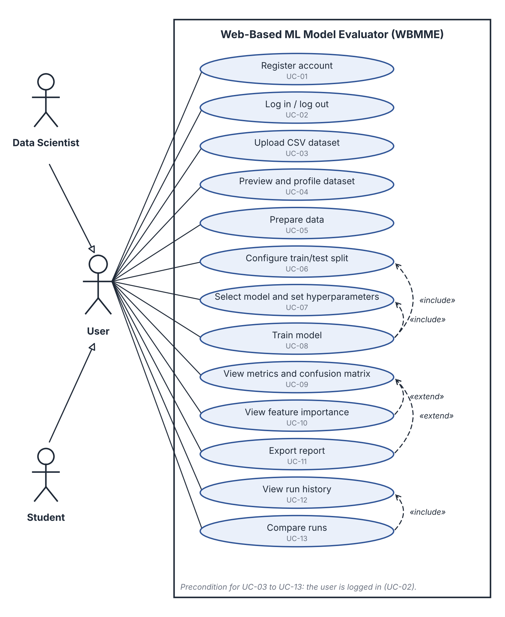
Figure 7-1: Use case diagram for the Student and Data Scientist roles

7.2 Administrator use cases
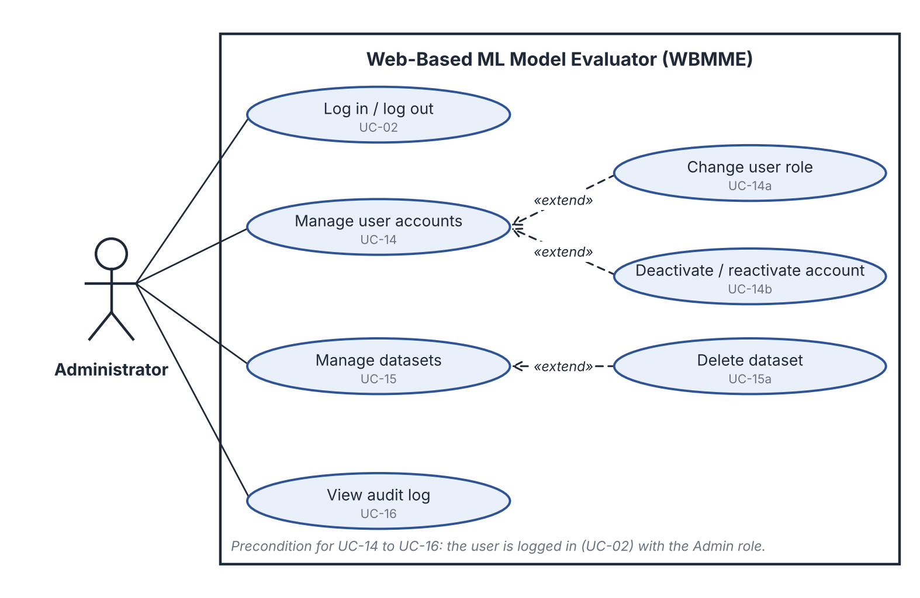
Figure 7-2: Use case diagram for the Administrator role

7.3 Use case summary
Table 7-1: Use cases and the requirements they realise
ID | Use case | Actor | Requirements
UC-01 | Register account | User | MLE-F-001
UC-02 | Log in / log out | User, Administrator | MLE-F-001, F-002, SR-001, SR-007
UC-03 | Upload CSV dataset | User | MLE-F-003, SR-003
UC-04 | Preview and profile dataset | User | MLE-F-004
UC-05 | Prepare data | User | MLE-F-005
UC-06 | Configure train/test split | User | MLE-F-006
UC-07 | Select model and set hyperparameters | User | MLE-F-007, F-008
UC-08 | Train model | User | MLE-F-009, SR-006
UC-09 | View metrics and confusion matrix | User | MLE-F-010, F-011
UC-10 | View feature importance | User | MLE-F-012
UC-11 | Export report | User | MLE-F-015
UC-12 | View run history | User | MLE-F-013
UC-13 | Compare runs | User | MLE-F-014
UC-14 | Manage user accounts | Administrator | MLE-F-016
UC-14a | Change user role | Administrator | MLE-F-016
UC-14b | Deactivate / reactivate account | Administrator | MLE-F-016
UC-15 | Manage datasets | Administrator | MLE-F-016
UC-15a | Delete dataset | Administrator | MLE-F-016, SR-005
UC-16 | View audit log | Administrator | MLE-F-016, SR-005

8. Requirements Traceability Matrix (RTM)
Each requirement is traced forward to a use case, an architecture component (SAD 3.4), a design reference (SAD 3.8) and a test case or security check. Code file references are completed during implementation, as pull requests are merged. Test case IDs are those in Test Plan Appendix A; SV-nn are the security checks in Test Plan section 5.1. Test Plan section 13 shows the same mapping from the test side.
Req ID | Requirement (short) | Use case | Architecture component | Design reference | Code file | Test case(s) / check
MLE-F-001 | User registration and login | UC-01, UC-02 | Auth & Access Control | DS-Auth-01 (SAD 4.2 login sequence) | TBD | TC-AUTH-01
MLE-F-002 | Role-based access (Data Scientist, Student, Admin) | UC-02 (all use cases) | Auth & Access Control | DS-Auth-02 | TBD | TC-SEC-01
MLE-F-003 | Upload CSV dataset with validation | UC-03 | Data Workspace, File Store | DS-Data-01 (SAD 4.2 upload sequence, /api/upload) | TBD | TC-DATA-01, TC-DATA-02
MLE-F-004 | Preview and profile the dataset | UC-04 | Data Workspace | DS-Data-02 | TBD | TC-DATA-01
MLE-F-005 | Handle missing values and encode categories | UC-05 | Data Workspace | DS-Data-03 | TBD | Planned (Sprint 1)
MLE-F-006 | Configure target column and train/test split | UC-06 | Data Workspace | DS-Data-04 | TBD | TC-MODEL-01
MLE-F-007 | Select a model from the catalogue | UC-07 | Model Selection & Training | DS-Model-01 | TBD | TC-MODEL-01
MLE-F-008 | Configure hyperparameters | UC-07 | Model Selection & Training | DS-Model-02 | TBD | TC-MODEL-01
MLE-F-009 | Train a model and show status | UC-08 | Model Selection & Training | DS-Model-03 (/api/train) | TBD | TC-MODEL-01
MLE-F-010 | Compute accuracy, precision, recall, F1 | UC-09 | Evaluation & Explainability | DS-Eval-01 (/api/evaluate) | TBD | TC-EVAL-01
MLE-F-011 | Show confusion matrix and plots | UC-09 | Evaluation & Explainability, Web UI | DS-Eval-02 | TBD | TC-EVAL-01
MLE-F-012 | Feature importance / explanation | UC-10 | Evaluation & Explainability | DS-Eval-03 | TBD | Planned (Sprint 2)
MLE-F-013 | Save each run (history) | UC-12 | Experiment Mgmt & Reporting, Relational DB | DS-Exp-01 | TBD | TC-EXP-01
MLE-F-014 | Compare runs side by side | UC-13 | Experiment Mgmt & Reporting | DS-Exp-02 | TBD | TC-EXP-01
MLE-F-015 | Export results report | UC-11 | Experiment Mgmt & Reporting | DS-Exp-03 | TBD | TC-DATA-02 (step 3)  (planned, Sprint 2)
MLE-F-016 | Admin manages users and datasets | UC-14, UC-14a, UC-14b, UC-15, UC-15a, UC-16 | Auth & Access Control, Web UI | DS-Admin-01 | TBD | TC-SEC-01
MLE-NF-001 | Upload of up to 10 MB processed in 5 s or less | - | Data Workspace | Performance budget in SAD 3.7 (R1) | TBD | TC-PERF-01
MLE-NF-002 | Training of standard models on up to 50,000 rows in 60 s or less | - | Model Selection & Training | Background job design (SAD 3.6) | TBD | TC-PERF-02
MLE-NF-003 | Pages load in 3 s or less for 20 concurrent users | - | API Gateway, Web UI | Layered stateless API (SAD 3.5) | TBD | TC-PERF-03
MLE-NF-004 | Runs on Windows, Linux and macOS via Docker | - | Packaging / Deployment | SAD 3.6 (Docker) | TBD | Planned (Sprint 2)
MLE-NF-005 | Usable by a first-time user without training | - | Web UI | SAD 4.5 UX Design | TBD | Planned (Sprint 2)
MLE-NF-006  (new) | Failed jobs are contained; saved data survives restart | - | Model Selection & Training, Relational DB | Background job design (SAD 3.6, 3.7 R1) | TBD | Planned (Sprint 2)
MLE-NF-007  (new) | Keeps page-load limits with 20 datasets and 100 runs per user | - | Experiment Mgmt & Reporting, Relational DB | TBD (SAD 4.x) | TBD | Planned (Sprint 2)
MLE-SR-001 | Passwords stored hashed | - | Auth & Access Control | SAD 3.9 Spoofing | TBD | TC-AUTH-01, SV-01
MLE-SR-002 | All traffic over HTTPS (TLS 1.2+) | - | Deployment / Gateway | SAD 3.9 Information disclosure | TBD | SV-02  (planned, Sprint 2)
MLE-SR-003 | Uploads validated for type, size and content | - | Input Validation & Security Controls | SAD 3.9 Tampering | TBD | TC-DATA-02, SV-03
MLE-SR-004 | Only system-created model artifacts are loaded | - | Model Selection & Training | SAD 3.9 Tampering / EoP | TBD | SV-04  (planned, Sprint 2)
MLE-SR-005 | Per-user data isolation and audit log of actions | UC-16 | Auth, Logging & Audit | SAD 3.9 Repudiation, Information disclosure | TBD | TC-SEC-01, SV-05
MLE-SR-006  (new) | Request, job and run-time limits against abuse | - | Input Validation & Security Controls, API Gateway, Model Selection & Training | SAD 3.9 Denial of service | TBD | SV-06  (planned, Sprint 2)
MLE-SR-007  (new) | Session expiry, login throttling and CSRF protection | - | Auth & Access Control, Input Validation & Security Controls | SAD 3.9 Spoofing | TBD | TC-AUTH-01 (cookie flag only), SV-07, SV-08  (planned, Sprint 2)
Totals: 16 functional requirements, 7 non-functional requirements (3 performance, 1 portability, 1 usability, 1 reliability, 1 scalability), 7 security requirements and 3 security objectives (section 5.1.1).

